**THE PATTERNS COMPANY**

4th Floor, Bizness Square Junction Opposite Hitex Road, HITEC City, Madhapur, Hyderabad, Telangana 500084

+91-8500693113

+91-9392744210

[info@thepatternscompany.com](mailto:info@thepatternscompany.com)

https://[www.thepatternscompany.com](http://www.thepatternscompany.com/)



Website Report for [www.mahidharaprojects.com](http://www.mahidharaprojects.com/)

This report grades your website based on the strength of various SEO factors such as On Page Optimization, O Page Links, Social and more. The overall Grade is on a A+ to F- scale, with most major, industry leading websites in the A range. Improving your grade will generally make your website perform better for users and rank better in search engines. There are recommendations for improving your website at the bottom of the report. Feel free to reach out to us if you’d like us to help with improving your website’s SEO!

Audit Results for [www.mahidharaprojects.com](http://www.mahidharaprojects.com/)



**C**

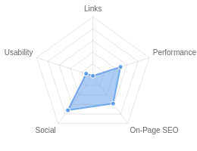**Your page could be better**



Recommendations: 21



**B-**



**F**



**F**



**C+**



**A-**

On-Page SEO

Links

Usability

Performance

Social

Recommendations

# Execute a Link Building Strategy

Links

High Priority

**Reduce your total page file size**

Performance

Medium Priority

# Optimize for Core Web Vitals

Usability

Medium Priority

**Reduce length of title tag (to between 10 and 70 characters)**

On-Page SEO

Medium Priority

# Shorten meta description (to between 70 and 160 characters)

On-Page SEO

Medium Priority

**Add H1 Header Tag**

On-Page SEO

Medium Priority

# Update Link URLs to be more human and Search Engine readable

Links

Low Priority

**Add Alt attributes to all images**

On-Page SEO

Low Priority

# Use your main keywords across the important HTML tags

On-Page SEO

Low Priority

**Increase page text content**

On-Page SEO

Low Priority

# Optimize your page for Mobile PageSpeed Insights

Usability

Low Priority

**Optimize your page for Desktop PageSpeed Insights**

Usability

Low Priority

# Add Schema Markup

On-Page SEO

Low Priority

**Add Twitter Cards**

Social

Low Priority

# Remove inline styles

Performance

Low Priority

**Resolve JavaScript errors**

Performance

Low Priority

# Remove clear text Email Addresses

Usability

Low Priority

**Increase your YouTube channel subscribers**

Social

Low Priority

# Review and Increase Font Sizes across devices

Usability

Low Priority

**Add Local Business Schema**

Other

Low Priority

# Improve Google Business Profile Rating & Review Count

Other

Low Priority

On-Page SEO Results

**Your On-Page SEO could be better**



**B-**

Your page has some level of On-Page SEO optimization but could be improved further. On-Page SEO is important to ensure Search Engines can understand your content appropriately and help it rank for relevant keywords. You should ensure that HTML Tag Content is completed correctly and align text content to target keywords.

# Title Tag

You have a title tag, but ideally it should be shortened to between 10 and 70 characters (including spaces).

Open Plots For Sale in Hyderabad, Bengaluru, Chennai | Villa Plots in Hyderabad - Mahidhara Projects

Length : 100

Title tags are very important for search engines to correctly understand and categorize your content.

# Meta Description Tag

Your page has a meta description tag however, your meta description should ideally be between 70 and 160 characters (including spaces).

Mahidhara Projects is a property development company which has successfully completed projects on residential villas in hyderabad,Luxury vilals in Bengaluru, Villas in bangalore, Open plots in chennai, Villas plots projects across in bangalore, Villas in kondavakkam, residential projects in oragadam.

Length : 302

A meta description is important for search engines to understand the content of your page, and is often shown as the description text blurb in search results.

# SERP Snippet Preview

This illustrates how your page may appear in Search Results. Note, this is intended as a guide and Search Engines are more frequently generating this content dynamically.

https://mahidharaprojects.com ⋮

Open Plots For Sale in Hyderabad, Bengaluru, Chennai

Mahidhara Projects is a property development company which has successfully completed projects on residential villas in hyderabad,Luxury vilals in ...

# Hreflang Usage

Your page is not making use of Hre ang attributes.

# Language

Your page is using the lang attribute. Declared: English

# H1 Header Tag Usage

Your page does not have an H1 Header Tag.

The H1 Header Tag is an important way of signaling to search engines what your content is about, and subsequently the keywords it should rank for.

# H2-H6 Header Tag Usage

Your page is making use multiple levels of Header Tags.

Header Tag Frequency

H2 9

H3 21

H5 10

H6 0

H4 0

# Keyword Consistency

Your page's main keywords are not distributed well across the important HTML tags.

Your page content should be focused around particular keywords you would like to rank for. Ideally these keywords should also be distributed across tags such as the title, meta and header tags.

Individual Keywords

Keyword Title Meta Description

Tag

Headings Tags Page Frequency

mahidhara    10

learn    9

acres    6

projects    6

villas    4

city    2

better    2

lifestyle    2

Phrases

Phrase Title Meta Description

Tag

Headings Tags Page Frequency

learn more

mahidhara







7

villas learn    4

acres learn    3

hyderabad bangalore

acres villas    2

   2

acres villas learn    2

# Amount of Content

Your page has a low volume of text content which search engines can interpret as 'thin content'.

Word Count: 232

It has been well researched that higher text content volumes are related to better ranking ability in general.

# Image Alt Attributes

You have images on your page that are missing Alt attributes.

We found 42 images on your page and 2 of them are missing the attribute.

Alt attributes are an often overlooked and simple way to signal to Search Engines what an image is about, and help it rank in image search results.

# Canonical Tag

Your page is using the Canonical Tag.

# Noindex Tag Test

Your page is not using the Noindex Tag which prevents indexing.

# Noindex Header Test

Your page is not using the Noindex Header which prevents indexing.

# SSL Enabled

Your website has SSL enabled.

# HTTPS Redirect

Your page successfully redirects to a HTTPS (SSL secure) version.

# Robots.txt

Your website appears to have a robots.txt le.

<http://www.mahidharaprojects.com/robots.txt>

# Blocked by Robots.txt

Your page does not appear to be blocked by robots.txt.

# XML Sitemaps

Your website appears to have an XML sitemap.

https://[www.mahidharaprojects.com/sitemap.xml](http://www.mahidharaprojects.com/sitemap.xml)

# Analytics

Your page is using an analytics tool.



Google Analytics

# Schema.org Structured Data

We have not detected any usage of Schema.org on your page.

Schema.org is a structured data markup for webpages which helps Search Engines understand your site better and provide rich snippets directly in their search results.

Rankings

# Top Keyword Rankings

This shows your top 10 Keyword Rankings in the speci c location. The list is ordered by the keywords that drive the most tra c to your page.

Keyword Country & Language

Position Total

Searches

Estimated Tra c



mahidhara harmony EN 1 1,900 577

mahidhara harmony  HI 1 1,900 577



oragadam HI 7 12,100 309

mahidhara paradise  EN 1 1,000 304



mahidhara luxuria EN 1 720 218

mahidhara projects  EN 1 590 179



mahidhara projects HI 1 590 179

mahidhara  EN 1 480 145



mahidhara fortune city EN 1 480 145

patancheru  EN 22 49,500 108

# Total Traffic From Search

This shows you the Estimated Tra c Volume your page receives from it’s Keyword Rankings



**3,859**

Monthly Tra c Volume

# Keyword Positions

This shows you a summary of the positions for your Keyword Rankings. The higher you rank, the more likely you are to capture tra c, with recent research showing that as much as 92% of clicks happen on the rst page.

Position Keywords

Position 1 14

Position 2-3 1

Position 11-20 7

Position 4-10 7

Position 21-30 17

Position 31-100 284

Links

# Backlink Summary

You have a reasonably weak level of backlink activity to this page.

Search Engines use backlinks as a strong indicator of a page's authority, relevance and ranking potential. There are various strategies available to gain links to a page to improve this factor



**6**



**2**

Domain Strength

Page Strength



**50.4k**

Backlinks

**513**

Referring Domains

|  |  |  |  |  |  |
| --- | --- | --- | --- | --- | --- |
| **42.4k**  Nofollow Backlinks | **8k**  Dofollow Backlinks | **0**  Edu Backlinks | **0**  Gov Backlinks | **142**  Subnets | **169**  IPs |

# Top Backlinks

These are the highest value external pages we have found linking to your site.

Domain strength

Referring Page URL

89 https://groups.diigo.com/group/realtor/content/tag/Plots

85 https://list.ly/list/2fa3-mahidharaprojects

82 https://app.crayon.co/f/about-page/?query=bengaluru

78 <http://sbmlist.16mb.com/user.php?login=mahidharaprojects&view=upvoted>

77 https://[www.skyscrapercity.com/threads/chennai-projects-update-thread-iii.516817/page-376](http://www.skyscrapercity.com/threads/chennai-projects-update-thread-iii.516817/page-376)

75 https://[www.sitelike.org/similar/24x7o](http://www.sitelike.org/similar/24x7o) er.com/

74 <http://websitescrawl.com/domain-list-299>

73 https://[www.debwan.com/blogs/288330/Open-Plots-Luxury-Villas-in-Pocharam-Hyderabad](http://www.debwan.com/blogs/288330/Open-Plots-Luxury-Villas-in-Pocharam-Hyderabad)

73 https://[www.emis.com/php/company-pro](http://www.emis.com/php/company-pro) le/IN/Mahidhara_Projects_Pvt_Ltd_en_4076812.html

73 https://viesearch.com/?q=%20chennai%20real%20estate

# Top Pages by Backlinks

These are the pages on your site with the most the backlinks from other sites.

URL Backlinks

<http://www.mahidharaprojects.com/> 2,213

<http://mahidharaprojects.com/> 1,285

<http://www.mahidharaprojects.com/our_vision> 968

[http://www.mahidharaprojects.com/project_view/30/Supreme-Budget-Housin...](http://www.mahidharaprojects.com/project_view/30/Supreme-Budget-Housin) 810

<http://www.mahidharaprojects.com/project_view/11/Mahidhara-Supreme> 764

<http://www.mahidharaprojects.com/about_us> 738

<http://www.mahidharaprojects.com/project_view/29/Fortune-City-Villas> 724

<http://www.mahidharaprojects.com/project_view/15/Mahidhara-Central-1> 736

<http://www.mahidharaprojects.com/project_view/7/Mahidhara-Fortune-City> 724

<http://www.mahidharaprojects.com/project_view/20/Mahidhara-Sarjapura> 718

# Top Anchors by Backlinks

These are the top pieces of Anchor Text we found used to link to your site.

Anchor Backlinks

[http://www.mahidharaprojects.com](http://www.mahidharaprojects.com/) 39,781

[http://www.mahidharaprojects.com](http://www.mahidharaprojects.com/) — 908

<http://www.mahidharaprojects.com/> 901

<http://mahidharaprojects.com/> 645

mahidharaprojects.com 474

Residential Properties in Bengaluru,Chennai|Upcoming Projects in Hyderabad-M ahidharaprojects

Villas and Plots For Sale in Chennai|Villas in Sriperumbudur,Chennai-Mahidharap 189 rojects

398

[http://mahidharaprojects.com](http://mahidharaprojects.com/) 152

[www.mahidharaprojects.com](http://www.mahidharaprojects.com/) 100

Residential Villas in Bangalore|Upcoming Housing Projects in Bengaluru-Mahidh 92 araprojects

# Top Referring Domain Geographies

These are the Top Geographies we have found linking to your site.

Top TLDs Top Countries

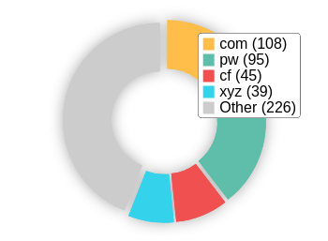 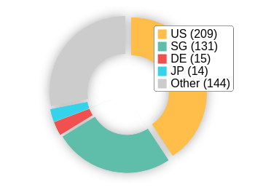

# On-Page Link Structure

We found 55 total links. 15% of your links are external links and are sending authority to other sites. 2% of your links are nofollow links, meaning authority is not being passed to those destination pages.

# Friendly Links

Some of your link URLs do not appear friendly to humans or search engines.

We would recommend making URLs as readable as possible by reducing length, le names, code strings and special characters.

Usability

# Your usability needs improvement



**F**

Your page has usability issues across devices. Usability is important to maximize your available audience and minimize user bounce rates (which can indirectly a ect your search engine rankings).

# Device Rendering

This check visually demonstrates how your page renders on di erent devices. It is important that your page is optimized for mobile and tablet experiences as today the majority of web tra c comes from these sources.

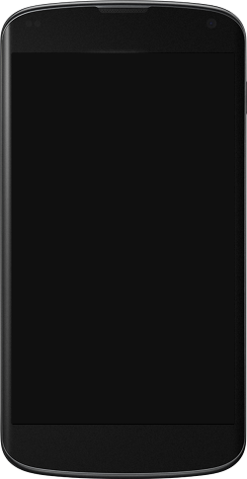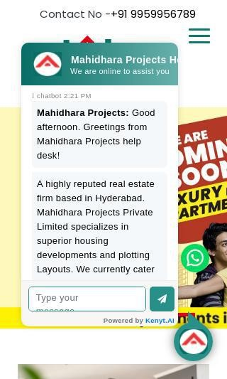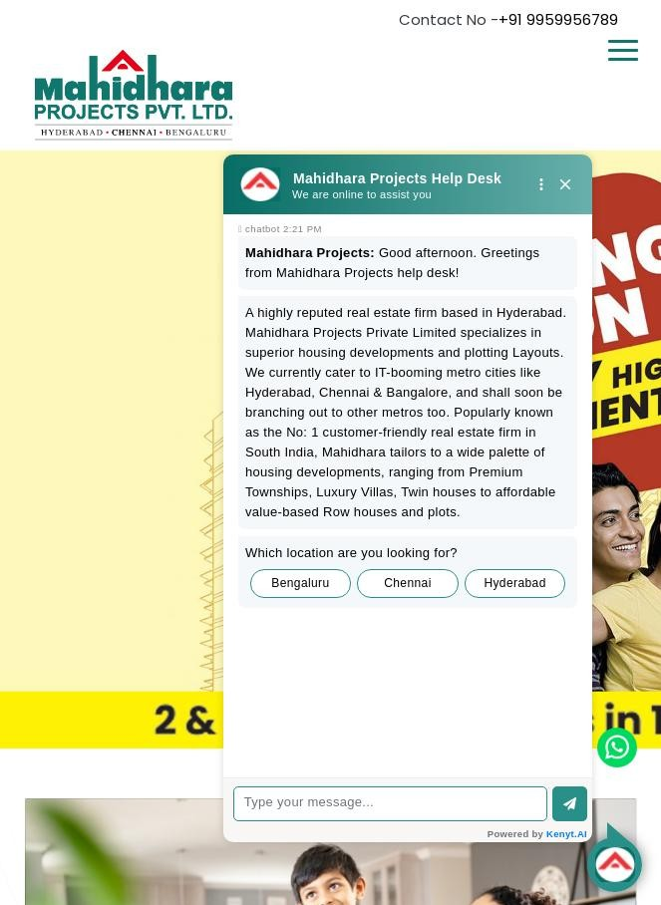

# Google's Core Web Vitals

Your page has failed Google's Core Web Vitals assessment.

Core Web Vitals are UI metrics created by Google that measure page experience and are becoming increasingly important as a ranking factor.

Largest Contentful Paint (LCP)

First Input Delay (FID)

Cumulative Layout Shift (CLS)

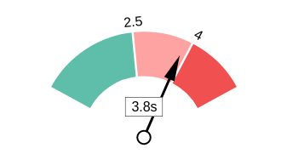 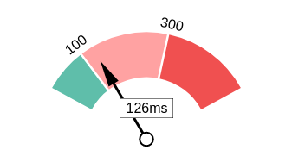 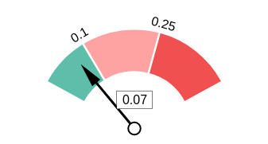

# Use of Mobile Viewports

Your page speci es a viewport matching the device's size, allowing it to render appropriately across devices.

# Google's PageSpeed Insights - Mobile

Google is indicating that your page is scoring poorly on their Mobile PageSpeed Insights evaluation.

Note that this evaluation is being performed from US servers and the results may di er slightly from an evaluation carried out from Google's PageSpeed Web Interface as that reporting localizes to the region in which you are running the report.

Google has indicated that the performance of a webpage is becoming more important from a user and subsequently ranking perspective.



**9**

Lab Data Value

First Contentful Paint 5.1 s

Opportunities Estimated Savings

Speed Index 16.7 s

Serve images in next-gen formats 19.72 s

Properly size images 7.98 s

Largest Contentful Paint 21.9 s

Time to Interactive 20.3 s

Total Blocking Time 1.07 s

Defer o screen images

3.76 s

|  |  |
| --- | --- |
| Reduce unused JavaScript | 1.88 s |
| Eliminate render-blocking resources | 1.87 s |
| Avoid multiple page redirects | 0.63 s |
| Reduce unused CSS | 0.47 s |
| Minify JavaScript | 0.47 s |
| Initial server response time was short | 0.15 s |

Cumulative Layout Shift 0.821

# Google's PageSpeed Insights - Desktop

Google is indicating that your page is scoring poorly on their Desktop PageSpeed Insights evaluation.

Google has indicated that the performance of a webpage is becoming more important from a user and subsequently ranking perspective.



**41**

Lab Data Value

First Contentful Paint 2.6 s

Opportunities Estimated Savings

Speed Index 5.2 s

Serve images in next-gen formats 3.15 s

Properly size images 1.05 s

Largest Contentful Paint 3.7 s

Eliminate render-blocking

resources

0.45 s

Time to Interactive 5.4 s

Total Blocking Time 0.1 s

Cumulative Layout Shift 0.636

Avoid multiple page redirects 0.19 s

# Flash Used?

Initial server response time was 0.17 s short

No Flash content has been identi ed on your page.

# iFrames Used?

There are no iFrames detected on your page.

# Favicon

Your page has speci ed a favicon.

# Email Privacy

Email addresses have been found in plain text.

We recommend removing any plain text email addresses and replacing them with images or contact forms. Plain text email addresses can be susceptible to scrapers and email spammers.

# Legible Font Sizes

There is some text on your page that is small and may not be legible enough for particular users.

We recommend reviewing all text on your page in di erent devices to ensure that it is of appropriate size.

# Tap Target Sizing

The links and buttons on your page appear to be appropriately sized for a user to easily tap on a touchscreen.

Performance Results

# Your performance could be better



**C+**

Your page's performance has some issues and room for improvement. Performance is important to ensure a good user experience, and reduced bounce rates (which can also indirectly a ect your search engine rankings). We recommend addressing the highlighted factors below.

# Page Speed Info

Your page loads in a reasonable amount of time.

Server Response All Page Content Loaded All Page Scripts Complete

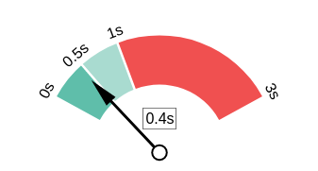 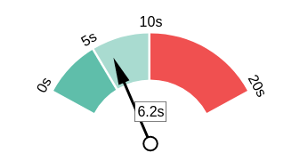 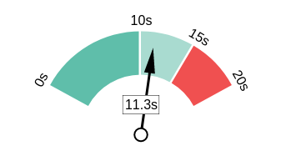

# Download Page Size

Your page's le size is quite large which, regardless of other optimizations, can reduce load speed and impact user experience.

A general rule is to keep your page under 5MB in total le size.

Download Page Size Download Page Size Breakdown

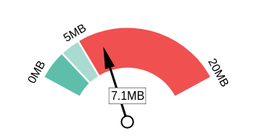 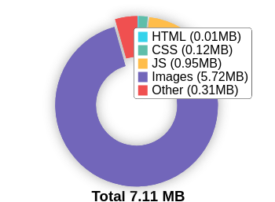

# Website Compression (Gzip, Deflate, Brotli)

Your website appears to be using a reasonable level of compression.

Compression Rates Raw Page Size Breakdown

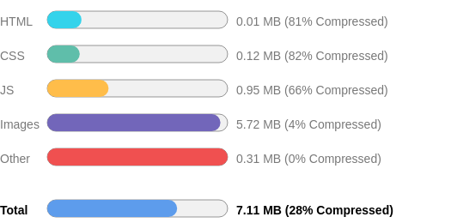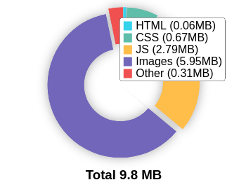

# Number of Resources

This check displays the total number of les that need to be retrieved from web servers to load your page.



**121**

Total Objects

**3**

Number of HTML Pages

**28**

Number of JS Resources

**18**

Number of CSS Resources

**46**

Number of Images

**26**

Other Resources

# Google Accelerated Mobile Pages (AMP)

This page does not appear to have AMP Enabled.

# JavaScript Errors

Your page is reporting JavaScript errors during load.

This could indicate that some required functionality on your page is failing or scripts may have coding problems.

# HTTP2 Usage

Your website is using the recommended HTTP/2+ protocol.

# Optimize Images

All of the images on your page appear to be optimized.

# Minification

All your JavaScript and CSS les appear to be mini ed.

# Deprecated HTML

No deprecated HTML tags have been found within your page.

# Inline Styles

Your page appears to be using inline styles.

Inline styles are an older coding practice and discouraged in favor of using CSS style sheets, due to their ability to degrade page load performance and unnecessarily complicate HTML Code.

Social Results

# Your social is good



**A-**

You have a reasonably good social presence. Social activity is important for customer communication, brand awareness and as a marketing channel to bring more visitors to your website. We recommend that you have all of your pro les listed on your page, and work to build a larger following on those networks.

# Facebook Connected

Your page has a link to a Facebook Page.

# Facebook Open Graph Tags

Your page is using Facebook Open Graph Tags.

# Facebook Pixel

Your page has a Facebook Pixel installed.

Pixel ID

1204622410402659

# Twitter Connected

Your page has a link to a Twitter pro le.

# Twitter Cards

We have not detected Twitter Cards on your page.

Twitter Cards are a type of structured data that can be placed on your page to control what content is shown when a page is shared on Twitter.

# Instagram Connected

Your page has a link to an Instagram pro le.

# LinkedIn Connected

Your page has a link to a LinkedIn pro le.

# YouTube Connected

Your page has a link to a YouTube channel.

**YouTube Activity ** You have a low number of YouTube channel subscribers.

 

**88**

Followers

**35,924**

View Count

Local SEO

# Local Business Schema

No Local Business Schema identi ed on the page.

# Google Business Profile Identified

A Google Business Pro le was identi ed that links to this website.



MAHIDHARA PROJECTS PVT LTD

# Google Business Profile Completeness

The important business details are present on the Google Business Pro le.

Address Madhapur, Hyderabad, Telangana 500081, India

Phone +91 40 4267 3399

Site https://[www.mahidharaprojects.com/](http://www.mahidharaprojects.com/)

# Google Reviews

Your Google Business Pro le has a low rating or low number of reviews.

3.9

★★★★★

113 reviews

Rating

5

4

3

2

1

Technology Results

# Technology List

These software or coding libraries have been identi ed on your page.

Technology Version



Apache HTTP Server

 Bootstrap 4.1.0



cdnjs

Cloud are



Facebook Pixel

 FancyBox



Font Awesome

 Google Analytics



Google Hosted Libraries

 Google Tag Manager

 Microsoft Clarity 0.7.20



jQuery



PHP 8.0.30

Popper 1.12.9



Slick

# Server IP Address

184.168.97.6

# DNS Servers

ns27.domaincontrol.com ns28.domaincontrol.com

# Web Server

Apache

# Charset

text/html; charset=UTF-8



[https://www.thepatternscompany.com](https://www.thepatternscompany.com/)

**The Purpose of a Business is to create a Customer Who Creates Customer’s**

**Thank you**